Chapter 16, Solution 62.

Using Fig. 16.85, design a problem to help other students better understand solving for node voltages by working in the s-domain.

Although there are many ways to solve this problem, this is an example based on the same kind of problem asked in the third edition.

Problem

Find the node voltages v₁ and v₂ in the circuit of Fig. 16.85 using Laplace transform technique. Assume that i_{s} = 12e^{-t} u(t) A and that all initial conditions are zero.

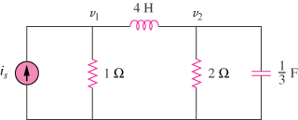

Figure 16.85
For Prob. 16.62.

Solution

The s-domain version of the circuit is shown below.
4s
V₁ V₂
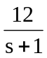 1 2 3/s

At node 1,

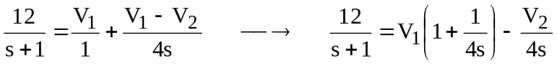 (1)

At node 2,

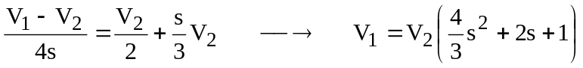 (2)

Substituting (2) into (1),

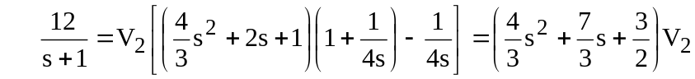

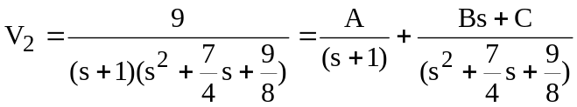

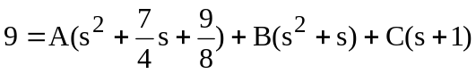

Equating coefficients:

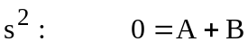
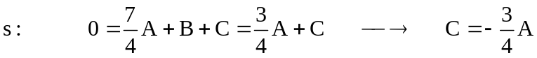

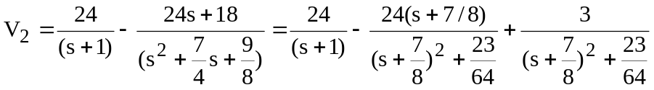
Taking the inverse of this produces:

Similarly,

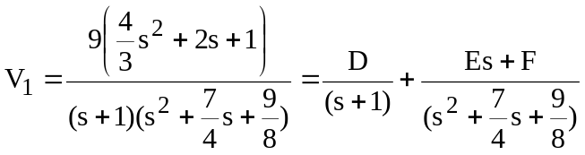

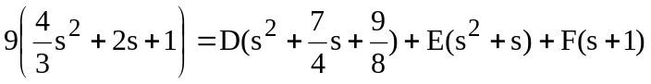

Equating coefficients:

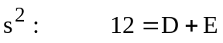
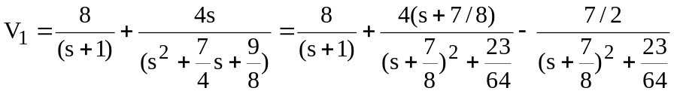
Thus,

